## ****TASK 1: Unit Testing with NUnit****

### Calculator.cs (Main Project - NUnitDemo)

namespace NUnitDemo

{

public class Calculator

{

public int Add(int a, int b) => a + b;

public int Subtract(int a, int b) => a - b;

public int Multiply(int a, int b) => a * b;

public double Divide(int a, int b)

{

if (b == 0) throw new DivideByZeroException();

return (double)a / b;

}

}

}

CalculatorTests.cs (Test Project - NUnitDemo.Tests)

using NUnit.Framework;

using NUnitDemo;

namespace NUnitDemo.Tests

{

public class CalculatorTests

{

private Calculator _calc;

[SetUp]

public void Setup()

{

_calc = new Calculator();

}

[Test]

public void Add_ShouldReturnSum()

{

Assert.AreEqual(8, _calc.Add(5, 3));

}

[Test]

public void Subtract_ShouldReturnDifference()

{

Assert.AreEqual(2, _calc.Subtract(5, 3));

}

[Test]

public void Multiply_ShouldReturnProduct()

{

Assert.AreEqual(15, _calc.Multiply(5, 3));

}

[Test]

public void Divide_ShouldReturnQuotient()

{

Assert.AreEqual(5.0, _calc.Divide(10, 2));

}

[Test]

public void Divide_ByZero_ShouldThrowException()

{

Assert.Throws<DivideByZeroException>(() => _calc.Divide(5, 0));

}

}

}

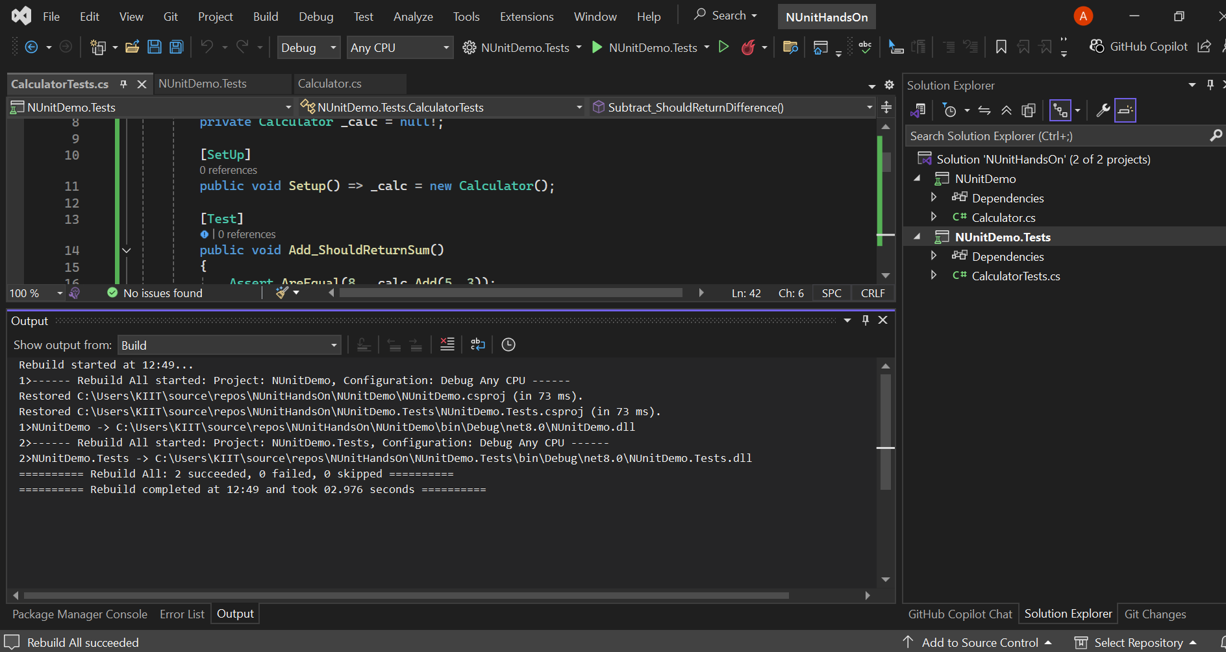

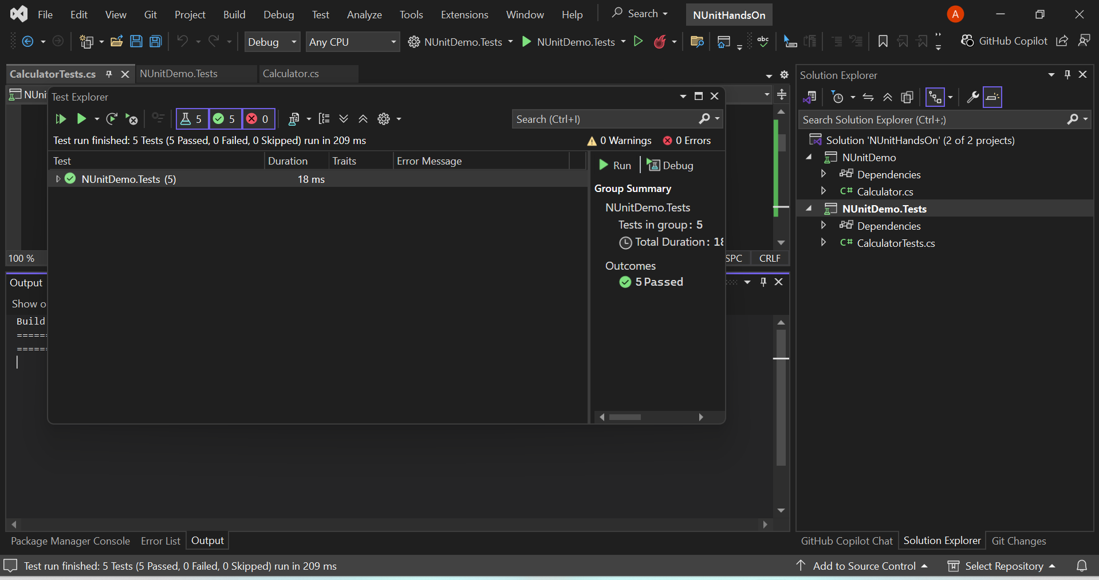

## ****TASK 2: Moq-Based Unit Testing****

IUserService.cs (Main Project - NUnitDemo)

namespace NUnitDemo

{

public interface IUserService

{

string GetUsername(int userId);

}

}

### 🔹 UserManager.cs (Main Project - NUnitDemo)

namespace NUnitDemo

{

public class UserManager

{

private readonly IUserService _userService;

public UserManager(IUserService userService)

{

_userService = userService;

}

public string GetGreeting(int userId)

{

var name = _userService.GetUsername(userId);

return $"Hello, {name}!";

}

}

}

### 🔹 UserManagerTests.cs (Test Project - NUnitDemo.Tests)

using Moq;

using NUnit.Framework;

using NUnitDemo;

namespace NUnitDemo.Tests

{

public class UserManagerTests

{

[Test]

public void GetGreeting_ShouldReturnCorrectMessage()

{

// Arrange

var mockUserService = new Mock<IUserService>();

mockUserService.Setup(us => us.GetUsername(1)).Returns("Ananya");

var userManager = new UserManager(mockUserService.Object);

// Act

var result = userManager.GetGreeting(1);

// Assert

Assert.AreEqual("Hello, Ananya!", result);

}

}

}

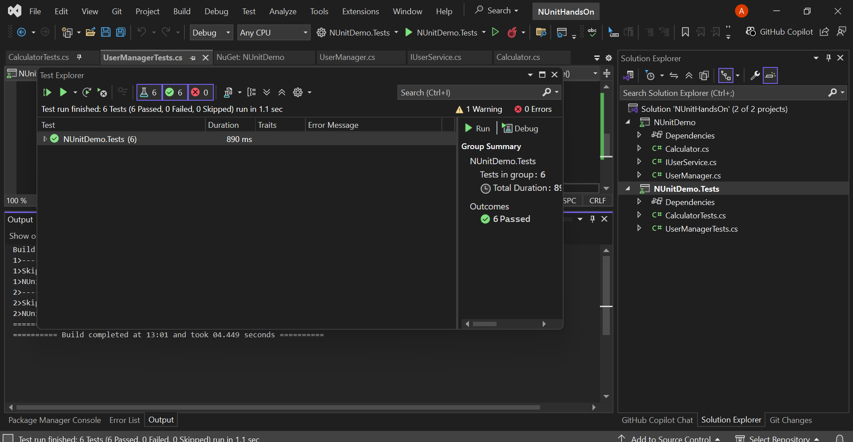

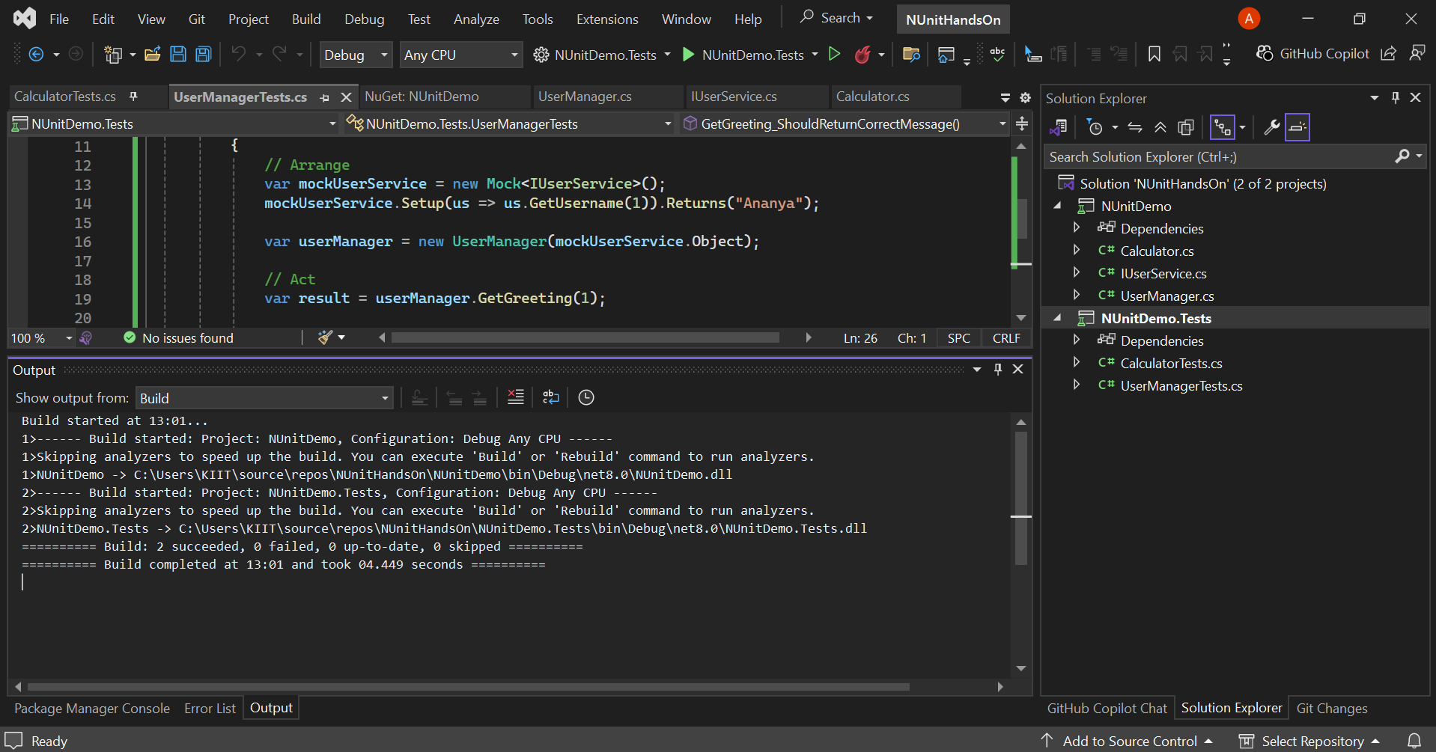

## Required NuGet Packages (install in NUnitDemo.Tests)

Install-Package NUnit -Version 3.13.3

Install-Package NUnit3TestAdapter -Version 4.5.0

Install-Package Microsoft.NET.Test.Sdk -Version 17.10.0

Install-Package Moq